## **Survey Platform**

## **Functional Requirements**

1. User Management
   * 1.1 User registration and authentication
   * 1.2 User roles (survey conductor, participant, administrator)
   * 1.3 User profile management
2. Survey Creation and Management
   * 2.1 Create, edit, and delete surveys
   * 2.2 Import/export survey questions (CSV format)
   * 2.3 Support various question types (MCQ, MSQ, rating scales, open-ended text, image ranking,coding)
   * 2.4 Embed media (images, videos, audio) in surveys
   * 2.5 Implement branching logic based on question responses
   * 2.6 Set video-dependent questions (locked until video playback criteria met)
3. Participant Recruitment
   * 3.1 Self-recruitment mode (generate shareable survey links)
   * 3.2 Platform recruitment service
     + 3.2.1 Define participant criteria
     + 3.2.2 Match surveys with registered participants based on criteria
4. Survey Taking
   * 4.1 Access surveys via web and mobile interfaces
   * 4.2 Pause and resume survey progress
   * 4.3 Save responses in real-time
   * 4.4 Support offline survey taking (sync when online)
5. Data Collection and Storage
   * 5.1 Collect and store individual responses
   * 5.2 Ensure response anonymity
   * 5.3 Option for self-hosted or cloud-based data storage
6. Analytics and Reporting
   * 6.1 Generate basic survey result reports
   * 6.2 Provide tools to sort and refine responses
   * 6.3 Export results in various formats (CSV, PDF, etc.)
7. Administration
   * 7.1 Platform configuration and management
   * 7.2 User management (create, modify, delete accounts)
   * 7.3 Monitor system usage and performance

## **Non-Functional Requirements**

1. Performance
   * 1.1 Support concurrent users: minimum 10,000 simultaneous users
   * 1.2 Response time: <2 seconds for 95% of requests
   * 1.3 Page load time: <3 seconds for complex surveys
2. Scalability
   * 2.1 Support for microservices architecture
3. Security
   * 3.1 End-to-end encryption for all data transmissions
   * 3.2 Regular security audits and penetration testing
   * 3.3 Multi-factor authentication option
4. Usability
   * 4.1 Intuitive, user-friendly interface for both conductors and participants
   * 4.2 Mobile-responsive design
5. Maintainability
   * 5.1 Modular architecture for easy updates and maintenance
   * 5.2 Comprehensive logging and monitoring
   * 5.3 Automated testing with >80% code coverage
6. Compatibility
   * 6.1 Support latest versions of major browsers (Chrome, Firefox, Safari, Edge)
   * 6.2 Mobile app support for iOS 13+ and Android 8+
7. Localization
   * 7.1 Multi-language support (initially English, with easy addition of other languages)
   * 7.2 Localization of date, time, and number formats
8. Data Integrity
   * 8.1 Implement data validation checks
9. Compliance
   * 9.1 Adhere to relevant survey and market research industry standards
   * 9.2 Implement ethical guidelines for survey conduct and data usage
10. Interoperability
    * 12.1 Provide RESTful APIs for integration with third-party systems
    * 12.2 Support standard data exchange formats (JSON, XML)

**Use Case Diagram**

Link: <https://app.eraser.io/workspace/ap1aYFlmiXNvKbAXcMVv>

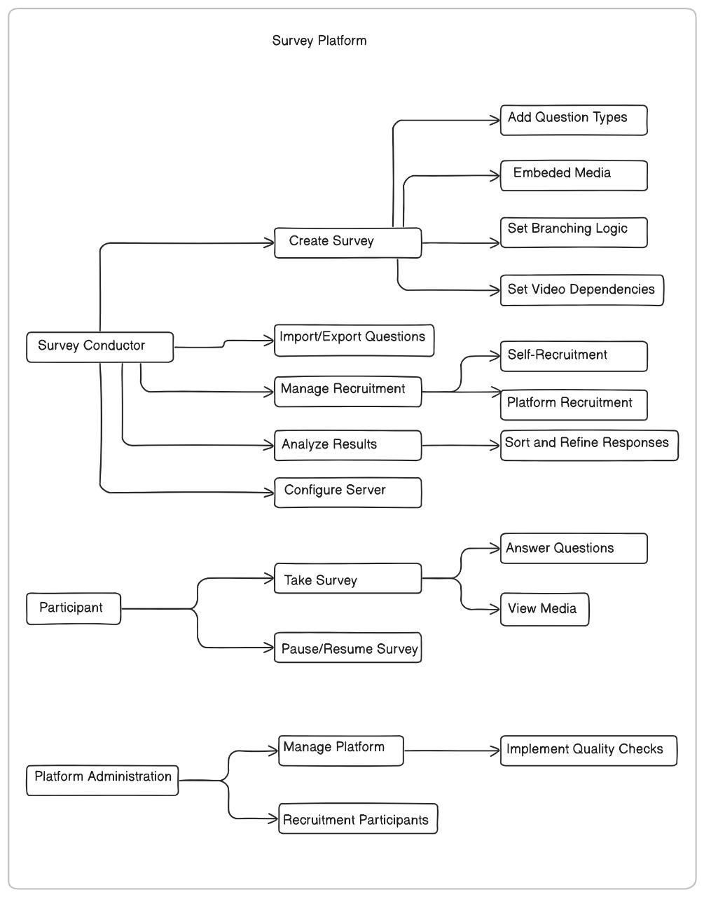

**High Level Design:**

**Link:**[**https://app.eraser.io/workspace/qb3PHL2DqKzO8gRHAS7O**](https://app.eraser.io/workspace/qb3PHL2DqKzO8gRHAS7O)

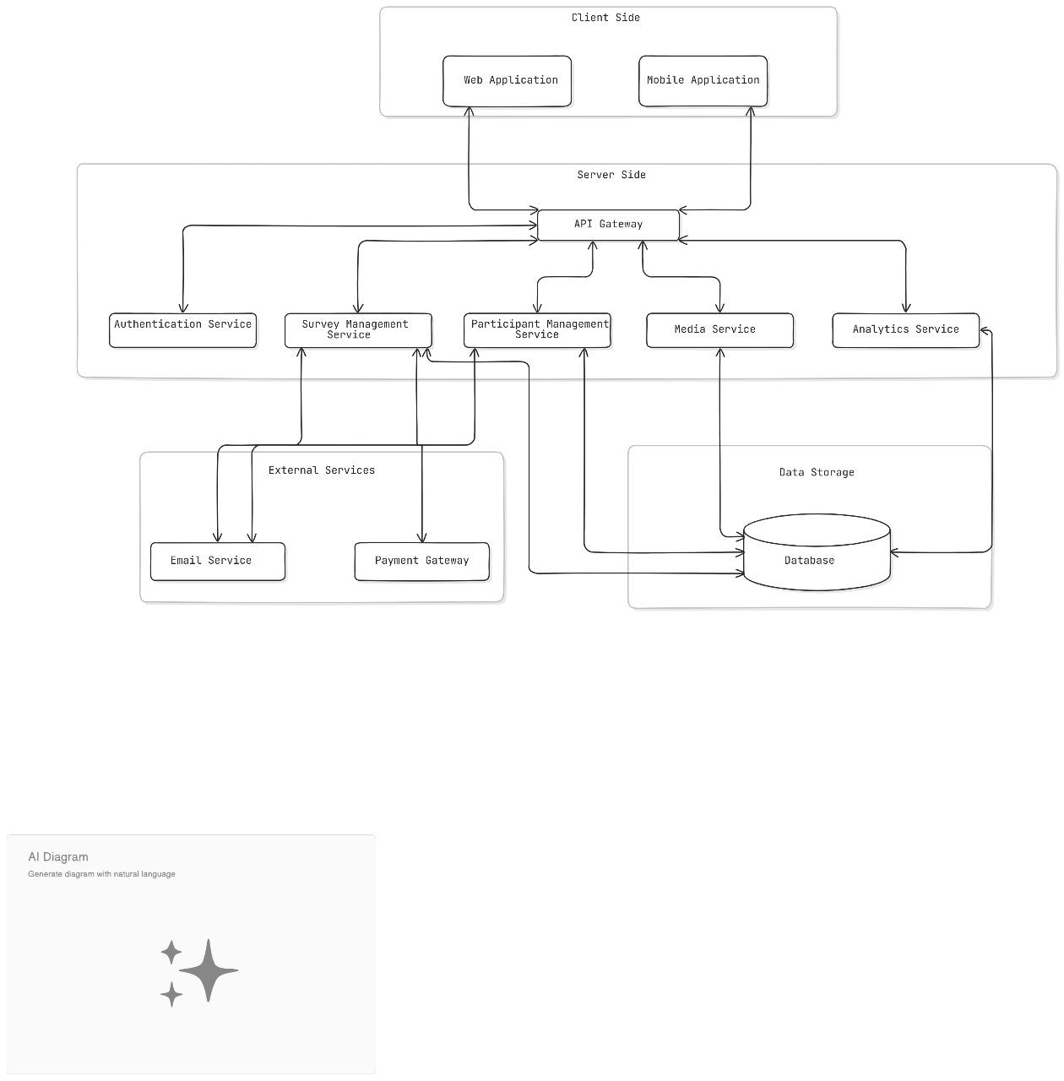

**Database Schema:**

**Link:** [**https://app.eraser.io/workspace/aagyHzT5gYtCyaKQmICf**](https://app.eraser.io/workspace/aagyHzT5gYtCyaKQmICf)

